Lab 6 SVMs

John Robinson

I struggled with this one, I got a linearly separable dataset off of GitHub, pulled two of the columns from the dataset that were linearly separable and plotted them.

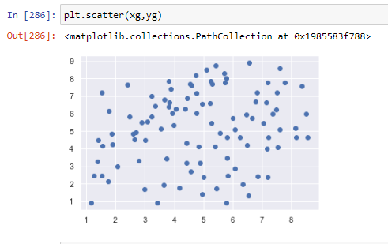

Training for linear SVM model

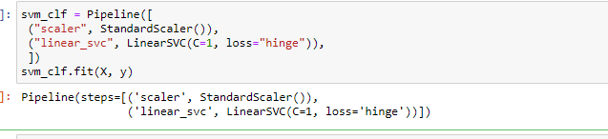

Then tested for linear separability with some predictor values, I know I am missing the classifier now that I return to the assignment. I don’t know why I didn’t see that before but I just went off what I saw in the book on linear svm classification. Should’ve added SGDClassifier(loss="hinge", alpha=1/(m\*C)) but too late now.

Below I just did some guess and check on checking for linear separability. Tried what I thought made the slope for the linearly separable area.

